For this lab, the goal was to identify the corners of the image and based on that, be able to rectify the image correctly. There were a set of images given to us to perform this lab in a general perspective.

A driver script was created that iterate through all the images from the Images__Hello_World folder. Each image gets selected, upon which, the user then clicks on the corner points of the subject image, in this case, the sheet of paper saing “Hello World!”. The order of input matters as that dictates how the x and y coordinate positioning will be perceived. The first point should be the top-left of the paper followed by top-right, then bottom-right and finally bottom-left. This is then transformed to grayscale to avoid extra processing time. The obtained points get their respective x and y coordinates rounded.

This is an example of one of the images from the testing folder:

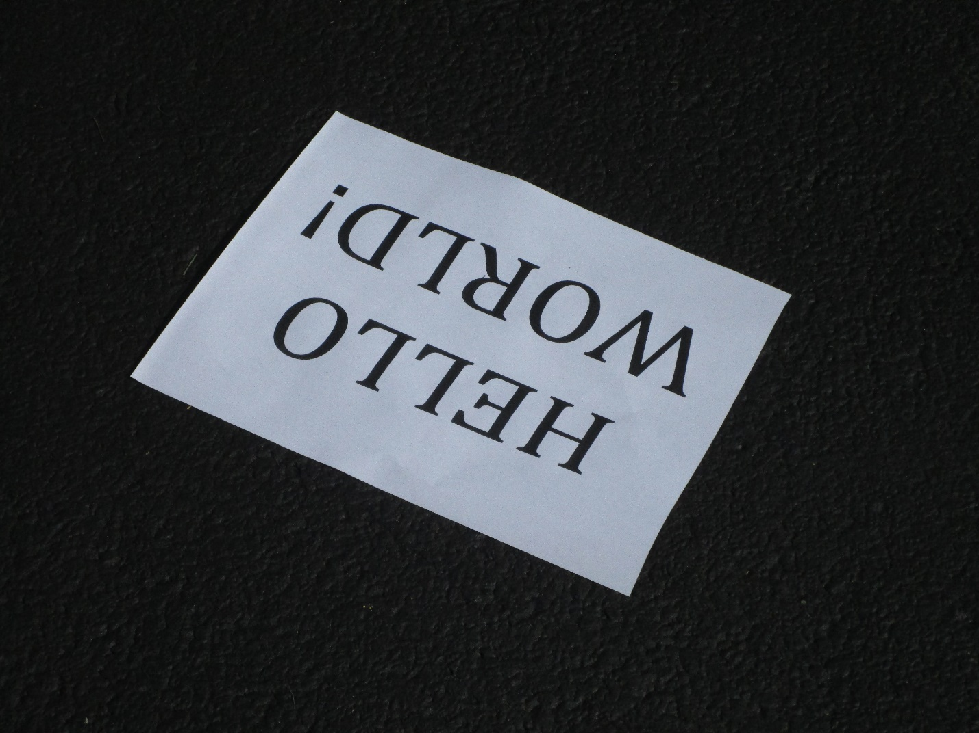

Image3987.jpg

Next, the transformation of the image occurs. The round points are projected to the set coordinate points that represent the size of the original image. The obtained image will be focused into the Paper and magnified, making the paper and its contents as the only subject matter. After the transformation, the resulting ‘transformed image’ is rectified and wrapped to the desired image. Each image is stored as a .png file.

The resulting image is:



I was not happy by my implementation of identifying the 4 corners of the image. I wanted to use the detectHarrisFeatures() to find the corners automatically, however, they were not identifying them correctly. I was able to get over 1000 points that was able to surround the image, however, the 4 corners were arbitrary. Even by binarizing them, filling the holes in the middle of the page and then eroding away the white spaces, the corners were prominent enough to be considered as the main strong points. Thus, to still perform this lab, I implemented the use of ginput() that allowed me to manually input the coordinates of the corners.

I will try other methods in order to be able to make the 4 corners identifiable as this concept will be a crucial technique during the project.